1. Find documents where the age is between 25 and 30:

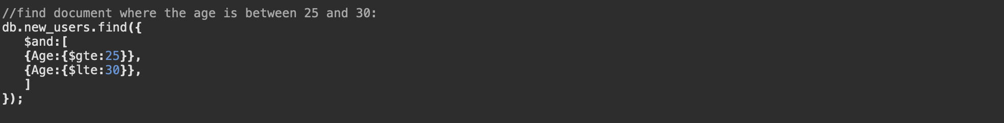

Result

1. Find all users with a bank balance > 500 in any bank



Result

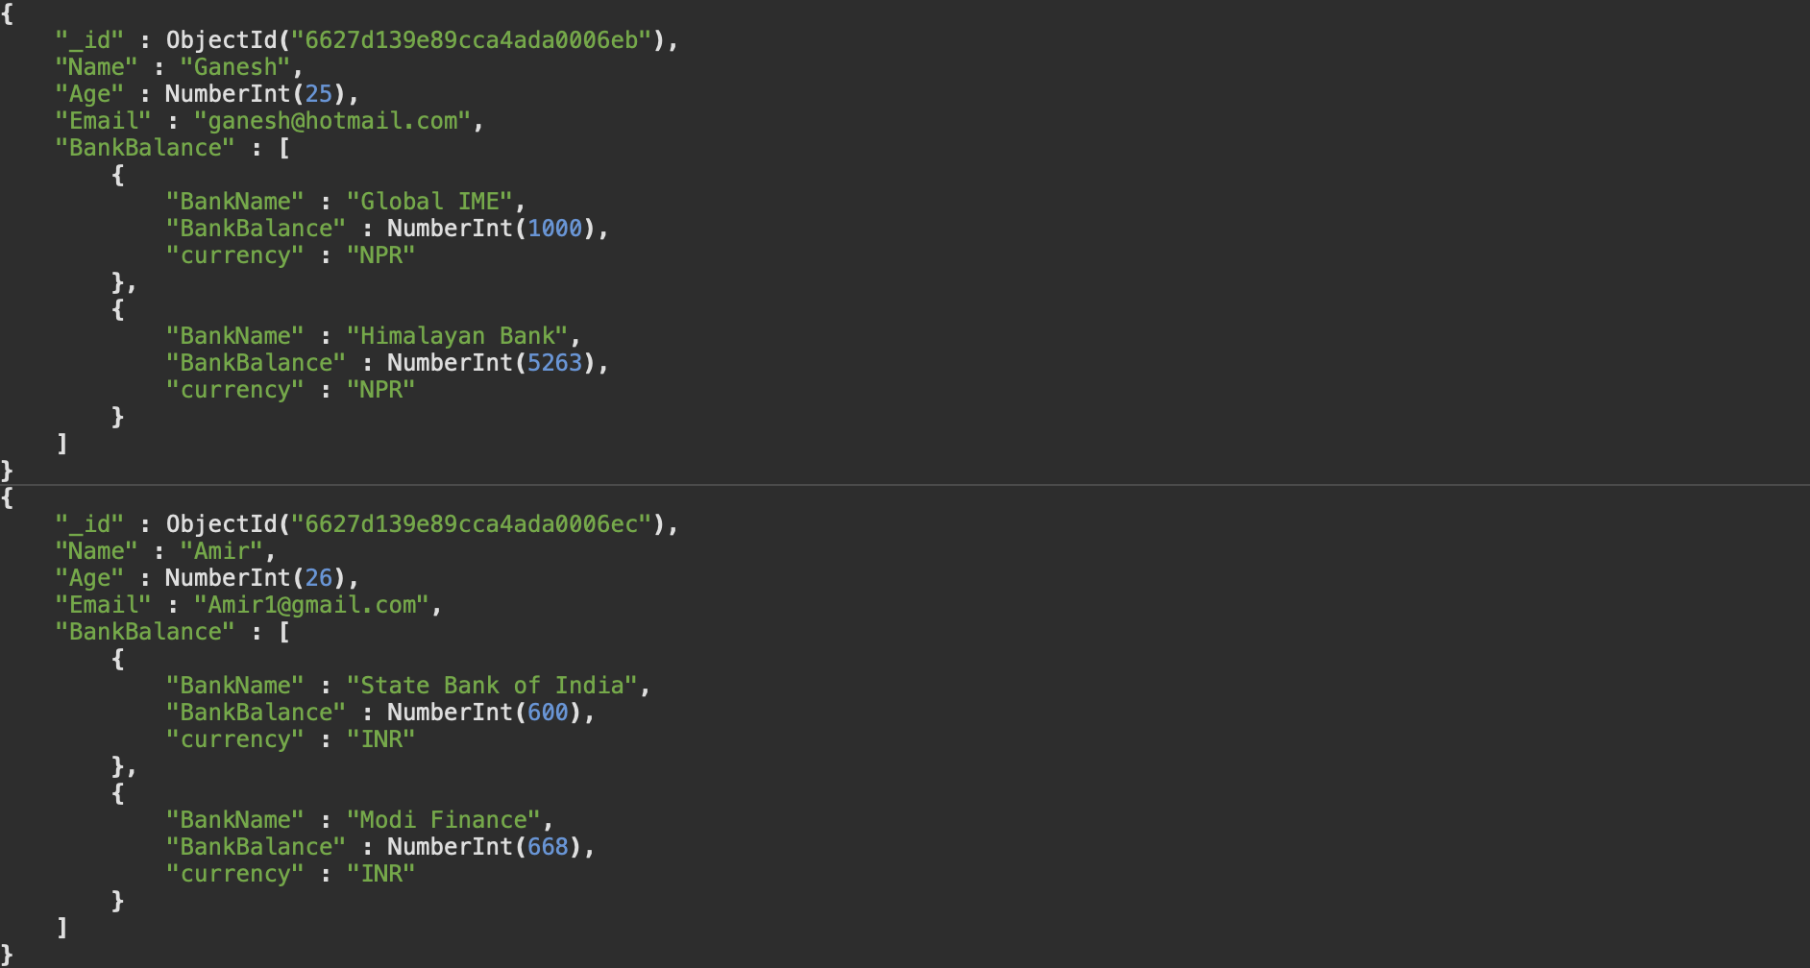

1. Update Ganesh's age to 26



Result

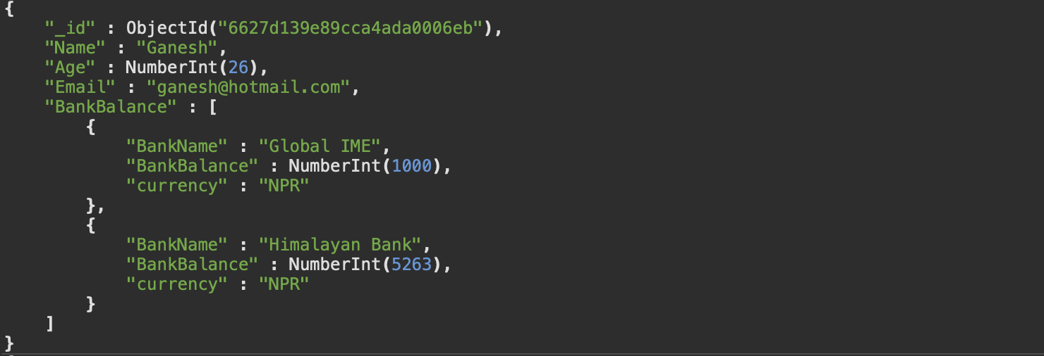

1. Add new bank for Helen (California State Bank, 9K)



Result

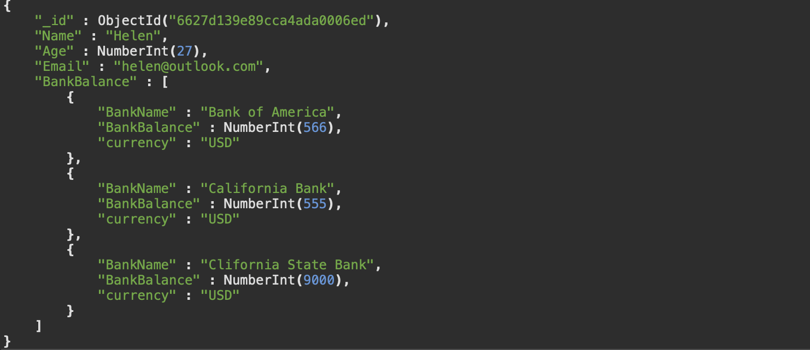

1. Rename California Bank to California SavingsAdd new bank for Helen



Result

1. Find documents with only the name and email fields included in the result:  
   

Result

1. Find the total number of documents in the collection:



Result



1. Find the user with the highest bank balance:

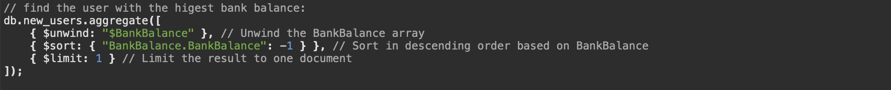

Result

